FIELD GUIDE • VERSION 1.0

Canon R Macro Watch
Photography Deep Dive
  - Maximizing your investment in the Canon EOS R10 and especially the exquisite RF100mm f/2.8L glass using tethered shooting for stunning watch images.
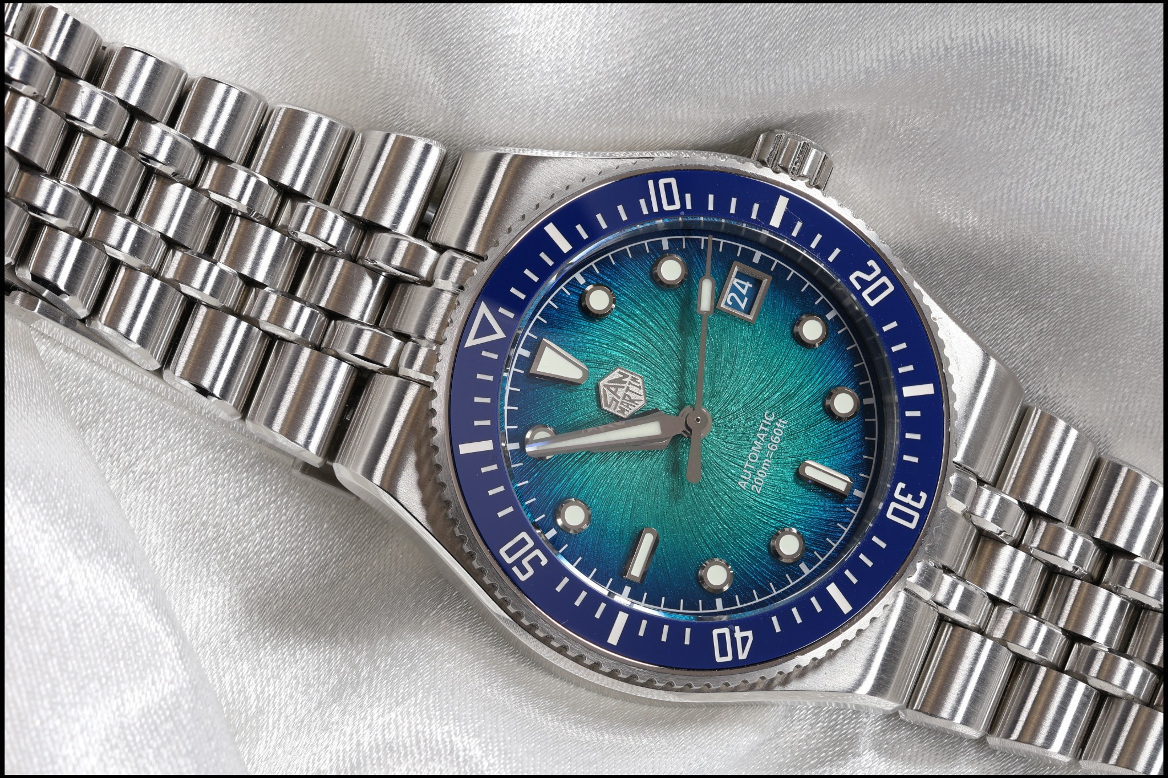
Lab milestone: first successful in-camera depth composite with the EOS R10 and RF100mm F2.8 L Macro IS USM.
A practical operating manual for the Canon EOS R10, RF100mm F2.8 L Macro IS USM, EOS Utility 3.20, and a tethered Windows watch-photography workstation.

How to Use This Guide
This is the master operating manual for a dedicated watch-photography lab. It is not a generic R10 manual. Every recommendation is filtered through one goal: sharp, repeatable, beautifully lit watch images with minimal contact with the camera once it is mounted overhead.
GOLDEN RULE: Use the camera body to establish a known-good C1 configuration, then use EOS Utility as the day-to-day control surface. Once the camera is mounted overhead, touching it should be the exception.

1 — The Watch Lab System

1.1 Core hardware
Component | Role | Watch-lab recommendation
Canon EOS R10 | APS-C camera body | C1 dedicated to macro watch work; C2 dedicated to walk-around photography.
RF100mm F2.8 L Macro IS USM | Primary macro optic | Lens switch AF; focus limiter FULL while learning; IS off on a rigid tripod; SA ring centered and locked.
RF28mm F2.8 STM | Walk-around lens | C2; Servo AF, tracking, people detection, Auto ISO.
Desk/overhead tripod | Camera support | Rigid, level, and isolated from the work surface as much as practical.
Windows laptop + USB-C | Tether station | EOS Utility 3.20.21.1; large Live View; remote exposure, focus, capture, and bracketing.
Luminar Neo | RAW development / finishing | Primary editor for finished CR3 files and composited JPEG/TIFF outputs.

1.2 Overhead geometry
For a full-watch overhead composition, begin around 16–20 inches from the camera sensor plane (the focal-plane mark on the body) to the watch. Treat 18 inches as a practical starting point, not a rule. Raise or lower the camera until the watch occupies roughly 70–80% of the frame, leaving 10–15% margin for straightening, alignment, and depth-composite cropping.
- Keep the sensor plane parallel to the watch dial for a flat catalog shot.
- For artistic angled compositions, intentionally tilt the watch or camera, then plan to use focus bracketing.
- At the RF100mm’s minimum focus distance, the sensor-to-subject distance is about 0.26 m / 10.2 in; a full watch normally needs more working distance than that.

2 — RF100mm Macro: Controls That Matter
Lens control | Watch-lab setting | Why
AF / MF | AF | Required for camera-driven focus bracketing; EOS Utility can still make very fine electronic focus moves.
Focus limiter | FULL | Avoids accidentally excluding the watch. Once your working distance is stable, the near range can speed AF.
Stabilizer | OFF on rigid tripod | Avoids unnecessary stabilization activity when the camera is solidly supported.
SA Control | Center / neutral; lock it | Preserves normal optical rendering and avoids deliberate spherical-aberration effects.

PROVEN TROUBLESHOOTING RESULT: If the RF100mm sometimes refuses to initiate AF after a very large near-to-far or far-to-near jump, set AF menu → Lens operation when AF is not available → Continue focus search. In our lab tests, this eliminated the apparently random silent failures seen with Stop focus search.

Why it happens: Canon explicitly states that Stop focus search may prevent lens drive when the focus is far off or cannot be achieved. The RF100mm has a very large focus range, so an extreme transition can leave the image so defocused that the camera declines to drive the lens. Continue focus search tells it to sweep until it finds usable focus information.

3 — C1: Watch Lab Gold Configuration
Category | Setting | Recommended value | Reason
Exposure | Mode | M | Repeatability.
Exposure | ISO | 100 | Maximum quality and dynamic range.
Exposure | Aperture | f/8 | Strong starting balance of sharpness and depth; stacking supplies total depth.
Exposure | Shutter speed | As required | Tripod removes the need for hand-holdable speeds.
Files | Image quality | RAW (.CR3) | Maximum editing latitude. Use C-RAW only if storage becomes a real constraint.
Files | HDR PQ | Off | Standard SDR workflow.
Files | HDR mode | Off | Controlled lighting is preferred.
AF | AF operation | One-Shot AF | Static subject; intentional focus acquisition.
AF | AF area | 1-point AF | Precise, user-chosen target.
AF | Subject tracking | Off | Avoid autonomous target changes.
AF | Subject to detect | None | No people/animal/vehicle logic.
AF | Eye detection | Disable | Irrelevant for watches.
AF | Preview AF | Off | Prevents background refocusing while composing.
AF | Lens operation when AF unavailable | Continue focus search | Prevents silent AF stalls after extreme focus-distance changes.
Controls | Shutter half-press | Metering only | Decouples exposure from autofocus.
Controls | AF-ON | Metering + AF start | Back-button autofocus.
Capture | Shutter mode | Electronic 1st-curtain | Good low-vibration starting point for tripod stills.
Capture | Drive | Single | Simple single-frame operation; bracketing manages its own sequence.
Lens | IS | Off | Rigid tripod.
Lens | Limiter | FULL | Maximum focusing range.
Lens | SA | Neutral + lock | Normal optical rendering.
Stacking | Focus bracketing | Enable when stacking | 2–999 source frames; sequence moves focus automatically.
Stacking | Exposure smoothing | On | Compensates brightness changes related to effective aperture across the stack.
Stacking | Depth composite | On while learning | Produces an immediate JPEG/HEIF composite and retains source images.
Stacking | Crop depth comp. | On for in-camera composite | Helps handle alignment/angle-of-view changes.

3.1 Register the configuration to C1
STEP Start in M mode and configure the camera exactly as desired.
STEP MENU → Set-up (yellow wrench) → Custom shooting mode (C1, C2).
STEP Choose Register settings → C1 → OK. The R10 copies the current shooting, menu, and Custom Function state into C1.
STEP Set Auto update set. to Disable so experiments made while shooting do not silently rewrite the master preset.
WORKFLOW HABIT: When you intentionally improve the C1 recipe, make the change in a normal creative mode, verify it, then re-register C1. Treat C1 as a gold-master configuration.

4 — C2: RF28mm Walk-Around Configuration
Setting | C2 recommendation | Why
Mode | Av | Fast control of depth of field.
Aperture | f/4 starting point | Compact lens stays sharp; open to f/2.8 when light or subject separation demands it.
ISO | Auto ISO, practical ceiling 6400 | Keeps the camera responsive in changing light.
Minimum shutter | 1/250 s starting point | Good baseline for people and street motion.
AF operation | Servo AF | Continuous focus while AF is held.
AF area | Whole area AF | Lets subject detection and tracking work broadly.
Subject to detect | People | Friends, family, street use.
Eye detection | Auto / Enable | Prioritizes eyes when available.
Subject tracking | On | Maintains selected subject.
Drive | High-speed continuous | Useful for candid movement.
Image quality | RAW | Same post-production latitude as the lab.
Back-button AF | Keep the same mapping as C1 | Consistent muscle memory.
Auto update | Disable | Preserves the preset.

5 — My Menu: Three Practical Tabs
The EOS R10 supports up to five My Menu tabs and up to six registered items per tab. We use three. This keeps the camera fast without turning My Menu into another maze.
Tab | Register these six items
MY MENU 1 — WATCH LAB | Focus bracketing; AF operation; AF area; Preview AF; Lens operation when AF unavailable; Image quality
MY MENU 2 — STUDIO | Shooting info. display; White balance; Shutter mode; Power saving; Screen brightness; Custom shooting mode (C1, C2)
MY MENU 3 — MAINTENANCE | Format card; Sensor cleaning; Firmware; Battery info; Copyright information; Reset camera

STEP MENU → My Menu (green star) → Add My Menu tab → OK.
STEP Open MY MENU*: Configure → Select items to register.
STEP Choose an item → SET → OK. Repeat until the tab is full.
STEP Use Sort registered items to place the most-used items first. Rename the tab if desired.

6 — Back-Button AF and the R10 Focus State

6.1 One-Shot AF
With Preview AF off and the shutter button separated from AF, One-Shot is wonderfully literal: press AF-ON to ask for one focus solution. When focus succeeds, Canon normally shows a green AF point. Release AF-ON and the lens remains at that focus distance until another AF command, manual focus move, or focus-bracketing sequence drives it.

6.2 Servo AF
Servo is for moving subjects. Hold AF-ON and the R10 continually updates focus. Canon documents that, in Servo AF, the AF point turns blue when focus is achieved. Release AF-ON and active Servo focusing stops, assuming Preview AF is off.
COLOR CAUTION: On the R10, Canon’s documentation uses green for successful One-Shot AF and blue for successful Servo AF; orange indicates failure. Treat color meaning in the context of the selected AF operation rather than as a universal progress indicator.

7 — EOS Utility 3.20: Tethered Watch-Lab Setup
The lab was validated with EOS Utility 3 version 3.20.21.1 on Windows. The interface looks dated, but it provides the control we need: exposure, white balance, Live View, focus placement, magnified inspection, electronic focus steps, remote release, and focus bracketing.
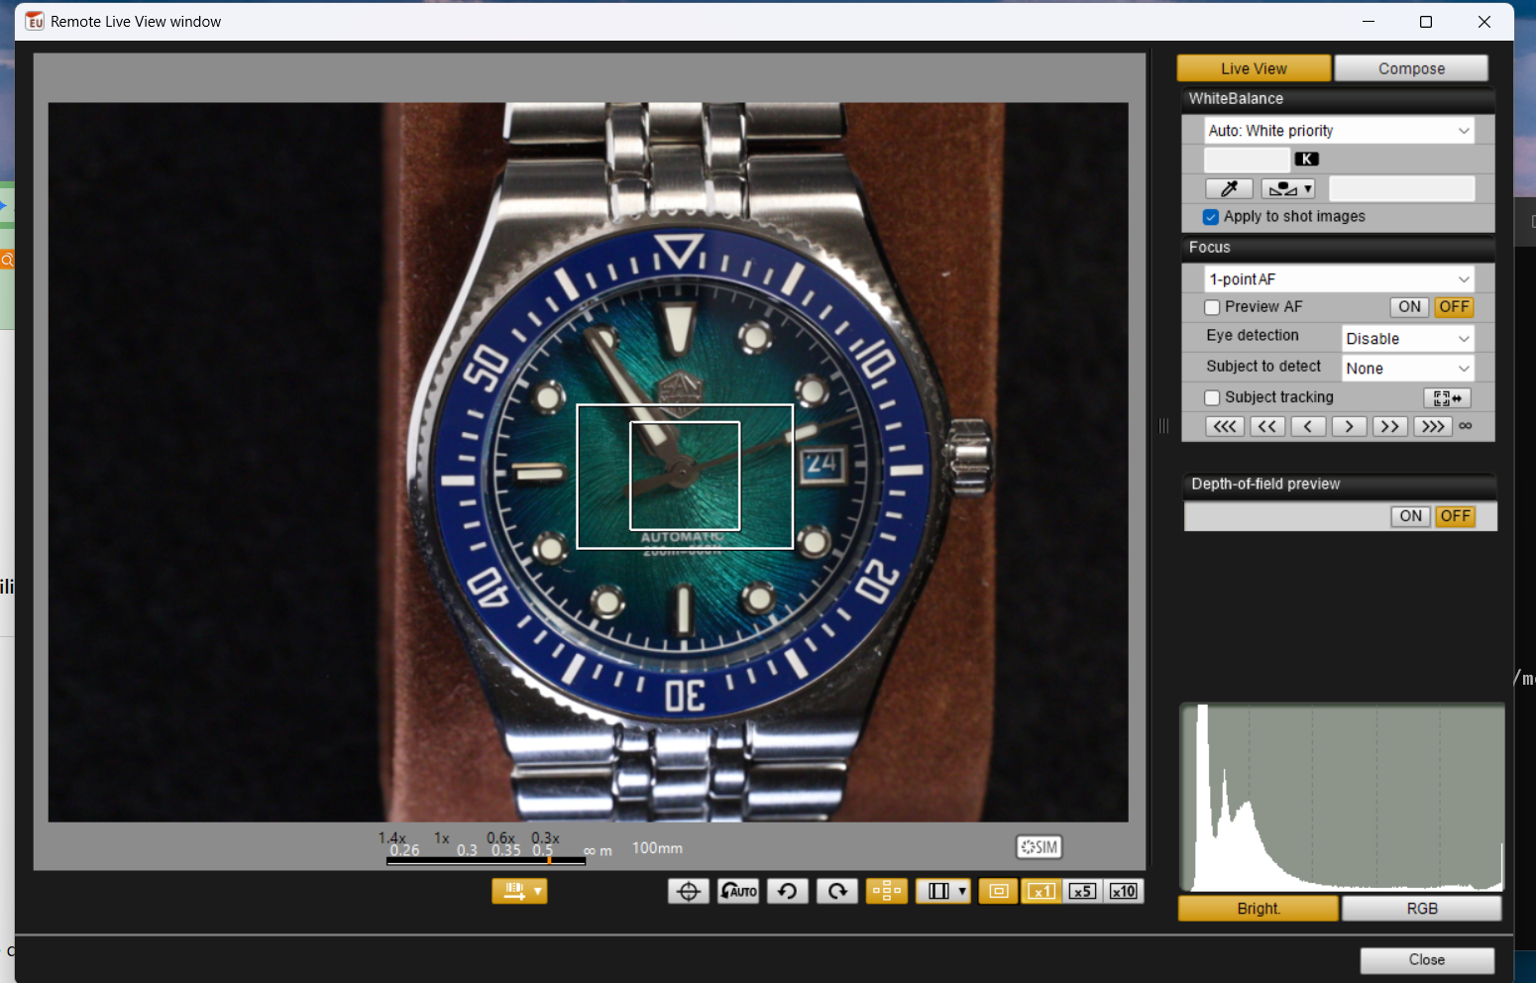
Figure 1. Remote Live View as used in the watch lab. The inner AF point, outer magnification frame, focus-distance overlay, histogram, and focus controls are visible.

7.1 Connect and establish destinations
STEP Set the R10 mode dial to C1 before mounting it where the physical dial is difficult to reach.
STEP Connect the R10 to the Windows laptop by USB-C and turn the camera on.
STEP Launch EOS Utility → Remote Shooting → Remote Live View.
STEP In the capture window, select the destination that records to both the computer and the camera/card when that option is shown. Confirm the PC destination folder in Preferences / Destination Folder.
STEP Take one test exposure and confirm that a CR3 appears in the PC folder and a matching image exists on the SD card.
WHY BOTH: The PC copy is available immediately for inspection and editing. The SD-card copy is an on-camera backup. Verify this once at the start of a session rather than assuming it.

7.2 What can be set from EOS Utility
Control | Watch-lab use
Shutter speed | Primary exposure control once ISO 100 and f/8 are fixed.
Aperture | Normally f/8; change deliberately for a test.
ISO | Normally 100.
White balance | Use a fixed value for repeatability; Live View can apply the selected white balance to shot images when “Apply to shot images” is checked.
Image quality | RAW recommended.
AF mode / focus controls | Keep One-Shot AF for the watch lab.
Destination | Computer + camera/card when available.
Picture Style | Affects JPEG and preview rendering; RAW sensor data remains available for later development.

8 — Reading the Remote Live View Window

8.1 The two rectangles
The two rectangles are not two independent autofocus zones. In our R10/EOS Utility 3.20 setup, the smaller inner rectangle is the AF point display. The larger outer rectangle is the magnification frame used for zoomed Live View. This is why the outer rectangle can be toggled independently and why double-clicking with only the outer frame visible magnifies rather than running AF.
LAB-VERIFIED BEHAVIOR: Inner AF point visible: double-click inside it → autofocus runs and a successful point turns green. Double-click elsewhere → EOS Utility moves the magnification/AF location there and opens a 5× view; the AF point remains white. Double-click the relocated AF point → AF runs. This two-step interaction is extremely useful for precise watch work.

8.2 Bottom toolbar, left to right
Control | What it does | Recommendation
Lens-distance display | Shows/hides the RF100mm distance/magnification scale | On; useful for macro context and troubleshooting.
Electronic level | Large animated pitch/roll overlay | Use briefly for setup; off while composing.
Auto Rotate | Automatically rotates Live View display | Usually on unless it fights your overhead orientation.
Rotate left / right | Manual display rotation; available when Auto Rotate is off | Use only when needed.
AF Point Disp | Shows/hides inner AF point | ON for remote autofocus.
Aspect ratio | Opens aspect-ratio controls | Leave 3:2 for RAW master captures.
Magnification frame | Shows/hides outer frame | On when positioning 5×/10× inspection.
×1 / ×5 / ×10 | Live View magnification | ×10 for final critical focus check.

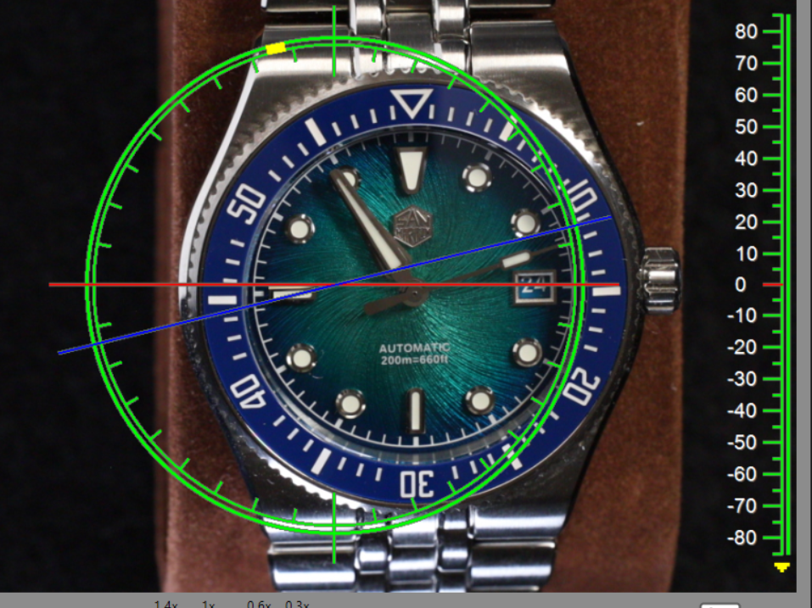
Figure 2. EOS Utility’s electronic level overlay. Powerful, accurate to approximately ±1° according to Canon, and visually exuberant.

9 — Perfect Single-Shot Workflow
STEP Clean the watch, crystal, bracelet, and background. Remove dust before it becomes a retouching project.
STEP Place the watch and set the overhead camera approximately 16–20 inches from sensor plane to watch. Compose with margin.
STEP Select C1. Confirm RF100mm: AF, FULL, IS off, SA neutral/locked.
STEP Open EOS Utility Remote Live View. Confirm M, ISO 100, f/8, fixed white balance, RAW, Preview AF off.
STEP Adjust shutter speed until highlights on polished steel are controlled. Use the histogram as a guardrail, not as an aesthetic target.
STEP Turn AF Point Disp on. Drag the inner square to a high-contrast feature on the dial, such as printed text or the edge of an applied index.
STEP Double-click inside the AF point to run One-Shot AF. Confirm the point turns green.
STEP Use 10× magnification to inspect focus. The small electronic focus steps can be used for final refinement; on our EOS Utility 3.20/R10 combination these nudges work even while the capture window remains in AF.
STEP Return to 1× and trigger the exposure from the capture window. Avoid touching the camera or tripod.
STEP Review at 100% on the PC. Check dial text, marker edges, crystal dust, bezel reflections, and clipped highlights.

10 — RAW, C-RAW, JPEG, and In-Camera Depth Composite

10.1 RAW vs C-RAW
The EOS R10 records standard RAW and Compact RAW as .CR3 files. For the watch lab, use standard RAW. C-RAW is a sensible storage-saving option, but our priority is maximum capture latitude for a permanent watch catalog. Storage is cheaper than re-shooting a carefully staged watch.

10.2 Do you need JPEG for Canon depth compositing?
No. Canon explicitly supports RAW or C-RAW source images for in-camera Depth Composite. When Depth Composite is enabled, the R10 saves the source images and also saves the composited result. The composite itself is JPEG or HEIF; Canon does not create a RAW composite.
Capture quality | Source frames retained | In-camera composite
RAW | RAW .CR3 | JPEG/HEIF
C-RAW | C-RAW .CR3 | JPEG/HEIF
JPEG/HEIF | JPEG/HEIF | JPEG/HEIF
RAW + JPEG/HEIF | Both source types | JPEG/HEIF

RECOMMENDATION: During the learning phase: RAW + Depth Composite ON. You get maximum-quality CR3 source frames plus an immediate camera-made JPEG composite. There is no need to record a separate JPEG for every source frame unless you specifically want it.

11 — Focus Bracketing and the First Full-Depth Watch Image
Focus bracketing captures a series in which the focal distance changes automatically after each shot. The important operational idea is to start at the nearest feature that must be sharp, then let the camera move focus progressively farther away.
Parameter | Starting value | How to tune it
Number of shots | 30 | Increase if the farthest required feature is not reached.
Focus increment | 3 | Lower if you see soft gaps; raise cautiously only when coverage is excessive.
Exposure smoothing | On | Recommended for depth compositing.
Depth composite | On while learning | Immediate JPEG/HEIF composite plus retained source frames.
Crop depth comp. | On | Helps alignment at the edges.

STEP Compose and expose exactly as for a single shot.
STEP Identify the nearest surface that must be sharp: nearest bezel edge, lug, crystal edge, or bracelet link.
STEP Move the AF point there, run AF, then inspect at 10×. Nudge focus if needed so the first plane is unquestionably covered.
STEP Enable Focus bracketing and enter the shot count, increment, exposure smoothing, and Depth Composite settings.
STEP Trigger the sequence once and do not touch the table, watch, camera, light stands, or cable until it finishes.
STEP Inspect the composite, then inspect first/middle/last source frames. If the stack stops too early, increase the shot count. If there are depth gaps, reduce the increment.

Figure 3. First successful in-camera focus-stacked watch image. The angled watch remains sharply rendered across dial, bezel, case, and bracelet, demonstrating why stacking is central to the lab workflow.

12 — Lighting: The Next Limiting Factor
Once focus stacking is reliable, the camera stops being the main problem. Watch photography becomes the controlled shaping of reflections. Polished steel is a mirror; brushed steel is a directional texture; sapphire is a reflector; a sunburst dial changes character with tiny changes in light angle.
- Use a large diffuse source above the watch to create broad, clean gradients.
- Use small white cards to add controlled highlights to dark case edges.
- Use black cards as negative fill to give polished surfaces shape and separation.
- Change one lighting variable at a time and record the result. Two inches can matter.
- Keep exposure and white balance fixed while comparing lighting variations.

13 — Watch Lab Startup Checklist
☐ Battery / USB power ready
☐ SD card present and space available
☐ Mode dial on C1
☐ RF100mm: AF / FULL / IS OFF / SA neutral + locked
☐ Tripod rigid and camera level
☐ Watch, crystal, bracelet, background clean
☐ Diffusion and lights in place
☐ EOS Utility connected and Remote Live View open
☐ Destination verified: PC + card
☐ RAW selected
☐ M / ISO 100 / f/8 / fixed white balance
☐ One-Shot / 1-point / tracking off / subject none / eye off
☐ Preview AF off
☐ Continue focus search enabled
☐ Histogram checked
☐ AF point visible
☐ Single-shot focus verified at 10×
☐ For stack: nearest plane chosen, bracketing settings checked

14 — Troubleshooting Notes
Symptom | Likely cause / action
AF silently does nothing after a huge distance change | Confirm Continue focus search. Stop focus search may intentionally prevent lens drive when focus is far off.
AF point turns orange/red | Focus was not achieved. Move to a higher-contrast edge, improve light, or allow focus search.
Camera refocuses after One-Shot even with no button held | Preview AF is probably on. Disable it for the watch lab.
EOS Utility double-click only magnifies | AF Point Disp is probably off, or the double-click was outside the inner AF point.
Cannot tell which box matters | Inner square = AF point. Outer frame = magnification frame.
In-camera composite has edge artifacts | Increase framing margin, enable crop depth composite, reduce focus increment, or use an external stacking application later.
Composite is JPEG even though sources are RAW | Normal. Canon’s in-camera depth composite output is JPEG/HEIF; source RAWs remain available.

Appendix A — EOS Utility Focus Keyboard Shortcuts
Adjustment | Closer | Farther
Large | I | O
Medium | K | L
Small | < (comma key with Shift as needed) | > (period key with Shift as needed)

Canon documents these as keyboard-based focusing controls. The exact key produced by your keyboard layout may display as < and >; in practical use the comma and period keys are the familiar fine-focus pair on a US keyboard.

Appendix B — Version 1.0 Decisions
- One master guide is the source of truth.
- Three short reference sheets are extracted from the master: Gold Configuration, Shooting Checklist, and EOS Utility Cheat Sheet.
- RAW is the standard watch-lab capture format.
- Depth Composite stays ON during the learning phase for instant feedback; the RAW source stack is preserved for later external stacking.
- C1 is the watch lab; C2 is walk-around with the RF28mm.
- Back-button AF remains consistent across C1 and C2.
- The EOS Utility workflow is validated against version 3.20.21.1 on Windows.

Appendix D — Technical Sources and Provenance
This guide deliberately separates Canon-documented behavior from lab-verified behavior observed on the EOS R10 with EOS Utility 3.20.21.1. The following official Canon references were used to confirm menu behavior and technical limits.
- EOS R10 Advanced User Guide — Focus Bracketing — Canon
- EOS R10 Advanced User Guide — Image Quality — Canon
- EOS R10 Advanced User Guide — AF Area — Canon
- EOS R10 Advanced User Guide — Customizing AF Functions — Canon
- EOS R10 Advanced User Guide — Custom Shooting Modes C1/C2 — Canon
- EOS R10 Advanced User Guide — My Menu — Canon
- EOS Utility 3.20 Manual — Remote Live View Functions — Canon
- EOS Utility 3.20 Manual — Remote Live View Shooting — Canon
- EOS Utility 3.20 Manual — Capture Window Functions — Canon
- EOS Utility 3.20 Instruction Manual — Canon

